1. **INTRODUCTION** 
   1. OVERVIEW

Financial performance analysis includes analysis and interpretation of financial statements in such a way that it undertakes a full diagnosis of the profitability and financial soundness of the business. The financial analyst program provides vital methodologies of financial analysis

* 1. PURPOSE

Although banks do many things, their primary role is to take in funds—called deposits—from those with money, pool them, and lend them to those who need funds. Banks are intermediaries between depositors (who lend money to the bank) and borrowers (to whom the bank lends money).

1. **PROBLEM DEFINITION AND DESIGN THINKING** 
   1. EMPATHY MAP

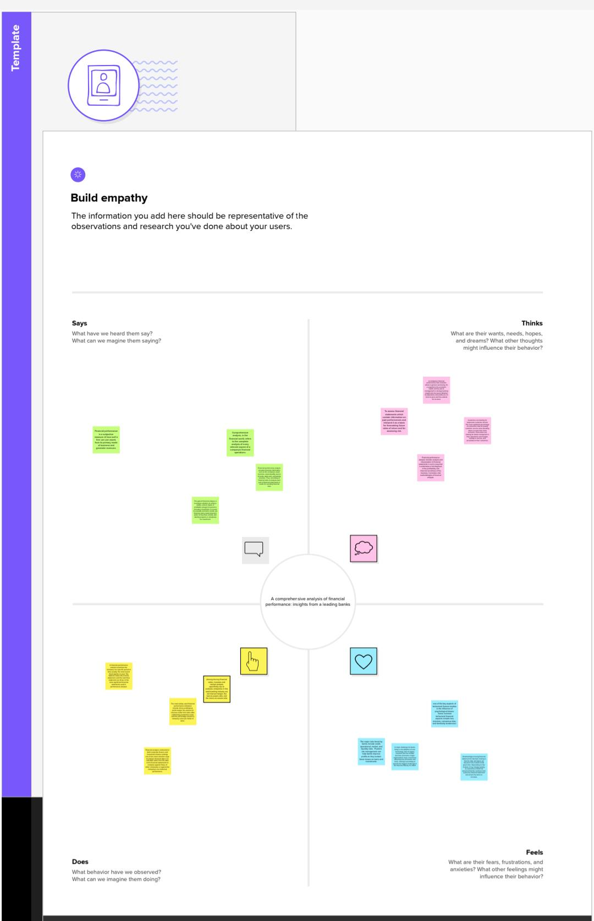

* 1. 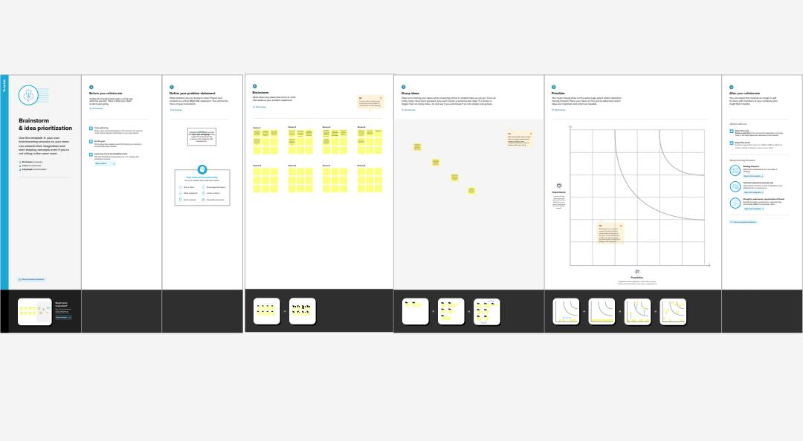IDEATION AND BRAINSTORMING MAP

1. **RESULT**

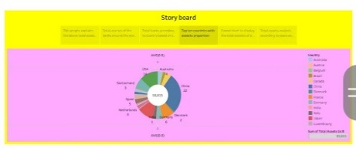

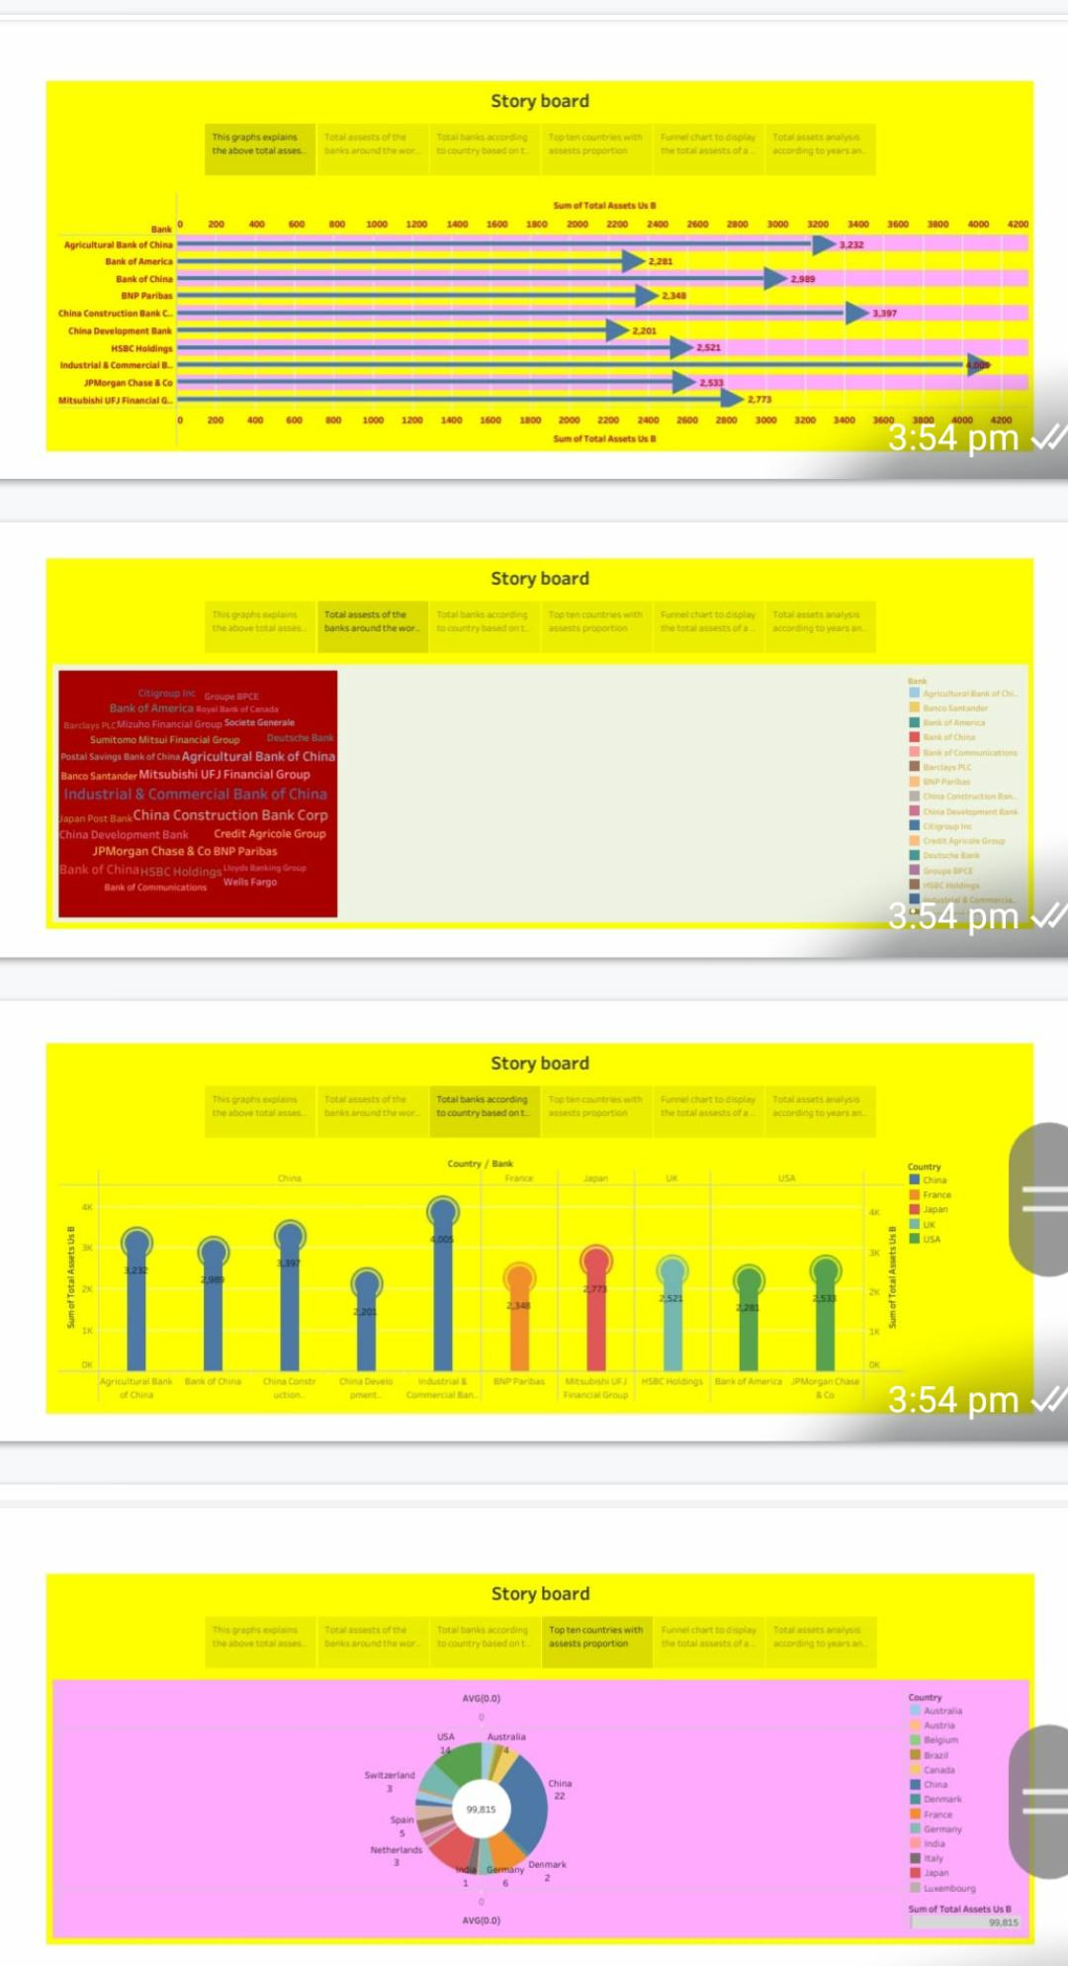

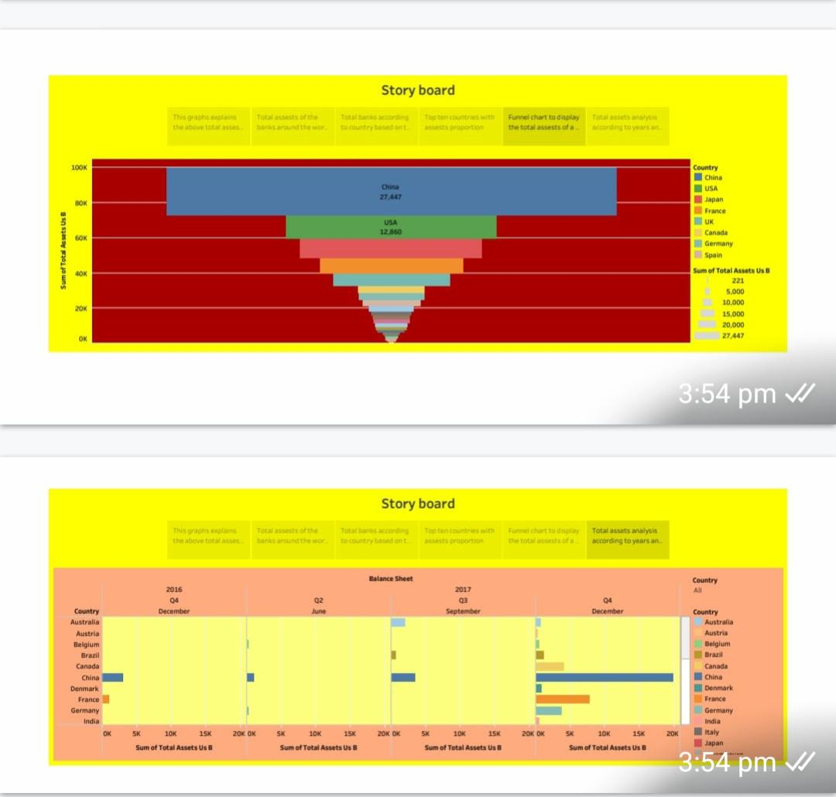

1. 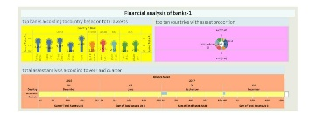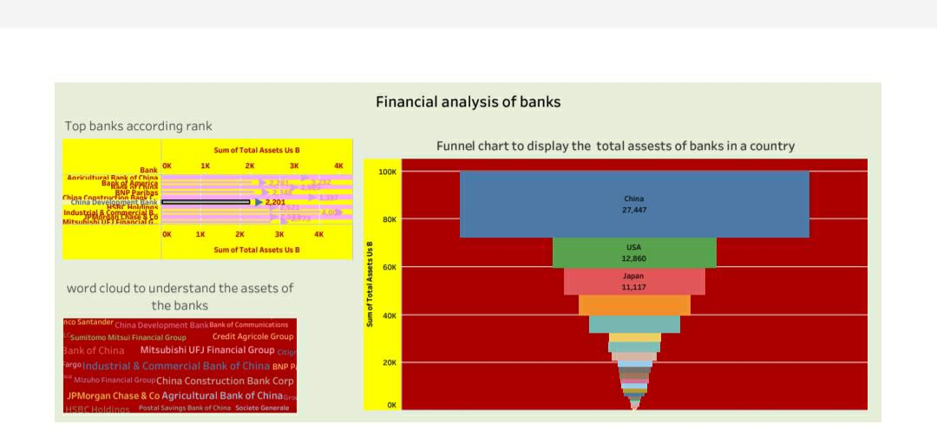 **ADVANTAGES AND DISADVANTAGES**

ADVANTAGES

1. company's financial performance tells investors about its general well-being. It's a snapshot of its economic health and the job its management is doing—providing insight into the future: whether its operations and profits are on track to grow and the outlook for its stock.

2. The Ability to Detect Patterns. Financial statements reveal how much a company earns per year in sales. ...

DISADVANTAGE

1. Measurement problems and a short-term concentration are two drawbacks of financial performance measurements.
2. Loans are not very flexible - you could be paying interest on funds you're not using. You could have trouble making monthly repayments if your customers don't pay you promptly, causing cashflow problems. In some cases, loans are secured against the assets of the business or your personal possessions, eg your home.
3. **APPLICATION**

Application Bank Refers to **a bank where all applications for the job of a vacancy is submitted** and it is their duty to select and reject these application for the further selection process according to the job qualification.

1. **CONCLUSION**

**Banking sector in Indian has given a positive and encouraging responses to the financial sector reforms**. Entry of new private banks and shaken up Public sector banks to competition. The financial sector reforms have brought India financial system closer to global standards.

1. **FUTURE SCOPE**

Such a bank will act as a financial assistant, with everything from payments and loans to investments and insurance taken care of, all while operating in the background, letting users focus on things more important to them.

1. **APPENDIX**

Customer segmentation is the approach of dividing a large and diverse customer base into smaller groups of related customers that are similar in certain ways and relevant to the marketing of a bank's products and services. Some basic segmentation criteria include geography, income and spending habits.